Performance Comparison of Single-Phase Cycloconverter with SiC Transistor and IGBT with Different Control Strategies

Karthik K Bhat

*Electronics and Communication Engineering*

*PES University*

Bengaluru, India.

karthikkbhat19@gmail.comMaithili J S

*Electronics and Communication Engineering*

*PES University*

Bengaluru, India.

maithili.shetty15@gmail.com

Anoop Narayana

*Electronics and Communication Engineering*

*PES University*

Bengaluru, India.

anoopmithur@gmail.com

***Abstract*—Silicon Carbide (SiC) MOSFET devices exhibiting several advantages, including high blocking voltage, lower conduction losses, and lower switching losses, when compared to silicon-based devices have become commercially available, enabling their adoption into power supply products. This paper presents a novel approach to designing a cycloconverter using SiC MOSFETs as opposed to the conventional usage of IGBT. A comparative study is attempted between the two with respect to power loss, system efficiency, leakage current etc. Furthermore, different closed loop control strategies are used to control the speed of an induction motor using the SiC cycloconverter model designed in this paper. MATLAB/Simulink models and simulations are used to analyze the results for the above.**

***Keywords—*Cycloconverters, IGBT, Silicon Carbide MOSFET, PID controller.**

# INTRODUCTION

Wide-bandgap (WBG) based semiconductors such as Silicon Carbide (SiC) or Gallium Nitride (GaN) are ready to carve out a niche in applications that demand the ability to work at high voltages and temperatures while demonstrating high efficiency and relatively smaller dimensions owing to their intrinsic properties. These WBG based semiconductors offer several advantages over the equivalent silicon devices available in the market today, few of which include, lower leakage current, significantly higher operating temperatures, better conduction and switching properties. For these reasons, the WBG devices have been identified to have a promising future in the power semiconductor industry.

Here the focus is only on the Silicon Carbide based Power devices and its applications. There has been a tremendous amount of research effort on developing power semiconductor devices with Silicon Carbide (SiC) in the pursuit of higher efficiency and smaller dimensions [1,2]. The availability of SiC wafers on a commercial basis has led to the demonstration of many types of metal-oxide semiconductor (MOS)-gated devices that exploit its unique properties. These emerging Silicon Carbide (SiC) MOSFET power devices promise to displace Silicon IGBTs from the majority of challenging power electronics applications by enabling superior efficiency and power density, as well as capability to operate at higher temperatures [3]. Reference [4] focuses on the comparison of a SiC based DC/DC converter and an IGBT based DC/DC converter and thus concludes that the efficiency of an SiC converter is greater than that of the IGBT converter over an output power range. An electro-thermal analysis of an automotive traction inverter platform based on SiC MOSFET and SiC IGBT technology is discussed in [5] and the results show that there is a higher total loss reduction in the SiC MOSFET model compared to the IGBT model. For all these reasons, in this paper, we are designing a cycloconverter using a SiC MOSFET as opposed to the usage of IGBT in doing the same.

In a cycloconverter, a constant voltage and frequency AC waveform is converted into another AC waveform of lower frequency without using DC link in the conversion process thus making it highly efficient [6]. A single-phase to single-phase cycloconverter consists of two full wave converters that are linked back to back. There has been extensive research carried out to explore the several possibilities for realizing an AC variable speed drive with cycloconverter. Reference [7] presents the different solutions and compares the performance of the cycloconverter in rolling mill drive applications. The speed control of induction motor plays an important role in industries, this can be made efficient by using various methods to control the action of the cyclo-converter which will control the motor performance [8], this paper uses the Silicon Carbide based cycloconverter for the speed control of a single phase induction motor using PID control strategy.

The objective of this paper is to design an efficient cycloconverter using SiC MOSFET and compare the performance of that with a cycloconverter designed using IGBT. The forthcoming sections give a better understanding of the above. SiC MOSFET is modelled using MATLAB/Simulink and a novel approach to design a cycloconverter using the same is presented. An analysis of all the simulation results and comparison of the performance of the SiC MOSFET and IGBT pertaining to various characteristics such as power loss, system efficiency, leakage current etc. is dealt with upon in the later sections Thereafter all the main results are concluded.

# SIMULINK MODEL

## Cycloconverter Design using IGBT

A cycloconverter for converting power at supply frequency to a lower frequency is modelled using IGBT as the switching element in Simulink. The converter has back to back connection of two full-wave rectifiers. The two-bridge type-controlled rectifiers are connected in anti-parallel direction via 4 ideal switched as represented in Fig. 1. The below model is used as a standard of comparison for the SiC model which is designed in this paper.

Fig. 1. Cycloconverter model using IGBT

The supply input to the cycloconverter is a 100V signal alternating at 50 Hz as in Fig, 2. The corresponding step-down output corresponds to a signal of 100V, alternating at a frequency of 5 Hz as shown in Fig, 3.

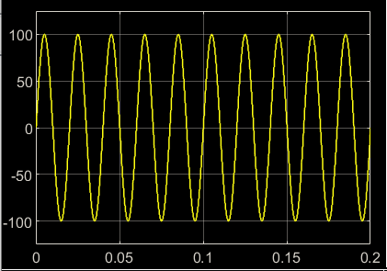

Fig. 2. Cycloconverter input

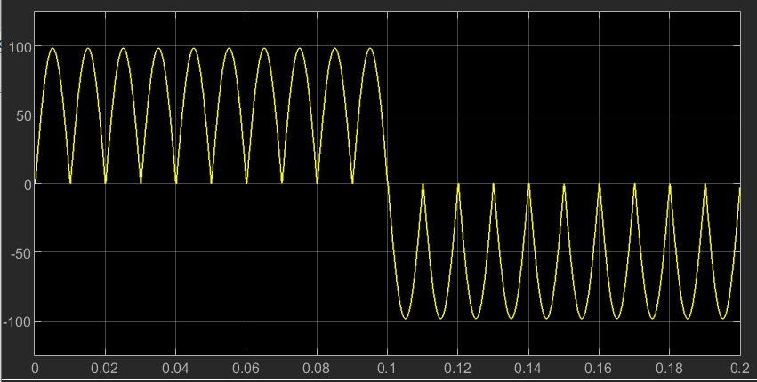

Fig. 3. Cycloconverter output

As is seen in the graphs an input of frequency of 50Hz is stepped down to a frequency of 5Hz.

Before you begin to format your paper, first write and save the content as a separate text file. Complete all content and organizational editing before formatting. Please note sections A-D below for more information on proofreading, spelling and grammar.

Keep your text and graphic files separate until after the text has been formatted and styled. Do not use hard tabs, and limit use of hard returns to only one return at the end of a paragraph. Do not add any kind of pagination anywhere in the paper. Do not number text heads-the template will do that for you?

## Abbreviations and Acronyms

Define abbreviations and acronyms the first time they are used in the text, even after they have been defined in the abstract. Abbreviations such as IEEE, SI, MKS, CGS, SC, dc, and rams do not have to be defined. Do not use abbreviations in the title or heads unless they are unavoidable.

## Units

* Use either SI (MKS) or CGS as primary units. (SI units are encouraged.) English units may be used as secondary units (in parentheses). An exception would be the use of English units as identifiers in trade, such as “3.5-inch disk drive”.
* Avoid combining SI and CGS units, such as current in amperes and magnetic field in oersteds. This often leads to confusion because equations do not balance dimensionally. If you must use mixed units, clearly state the units for each quantity that you use in an equation.
* Do not mix complete spellings and abbreviations of units: “Wb/m2” or “webers per square meter”, not “webers/m2”. Spell out units when they appear in text: “. . . a few henries”, not “. . . a few H”.

Identify applicable funding agency here. If none, delete this text box.

* Use a zero before decimal points: “0.25”, not “.25”. Use “cm3”, not “cc”. (*bullet list*)

## Equations

The equations are an exception to the prescribed specifications of this template. You will need to determine whether or not your equation should be typed using either the Times New Roman or the Symbol font (please no other font). To create multileveled equations, it may be necessary to treat the equation as a graphic and insert it into the text after your paper is styled.

Number equations consecutively. Equation numbers, within parentheses, are to position flush right, as in (1), using a right tab stop. To make your equations more compact, you may use the solidus ( / ), the exp function, or appropriate exponents. Italicize Roman symbols for quantities and variables, but not Greek symbols. Use a long dash rather than a hyphen for a minus sign. Punctuate equations with commas or periods when they are part of a sentence, as in:

*a*  *b*    

Note that the equation is centered using a center tab stop. Be sure that the symbols in your equation have been defined before or immediately following the equation. Use “(1)”, not “Eq. (1)” or “equation (1)”, except at the beginning of a sentence: “Equation (1) is . . .”

## Some Common Mistakes

* The word “data” is plural, not singular.
* The subscript for the permeability of vacuum *μ*0, and other common scientific constants, is zero with subscript formatting, not a lowercase letter “o”.
* In American English, commas, semicolons, periods, question and exclamation marks are located within quotation marks only when a complete thought or name is cited, such as a title or full quotation. When quotation marks are used, instead of a bold or italic typeface, to highlight a word or phrase, punctuation should appear outside of the quotation marks. A parenthetical phrase or statement at the end of a sentence is punctuated outside of the closing parenthesis (like this). (A parenthetical sentence is punctuated within the parentheses.)
* A graph within a graph is an “inset”, not an “insert”. The word alternatively is preferred to the word “alternately” (unless you really mean something that alternates).
* Do not use the word “essentially” to mean “approximately” or “effectively”.
* In your paper title, if the words “that uses” can accurately replace the word “using”, capitalize the “u”; if not, keep using lower-cased.
* Be aware of the different meanings of the homophones “affect” and “effect”, “complement” and “compliment”, “discreet” and “discrete”, “principal” and “principle”.
* Do not confuse “imply” and “infer”.
* The prefix “non” is not a word; it should be joined to the word it modifies, usually without a hyphen.
* There is no period after the “et” in the Latin abbreviation “et al.”.
* The abbreviation “i.e.” means “that is”, and the abbreviation “e.g.” means “for example”.

An excellent style manual for science writers is [7].

# Using the Template

After the text edit has been completed, the paper is ready for the template. Duplicate the template file by using the Save As command, and use the naming convention prescribed by your conference for the name of your paper. In this newly created file, highlight all of the contents and import your prepared text file. You are now ready to style your paper; use the scroll down window on the left of the MS Word Formatting toolbar.

## Authors and Affiliations

**The template is designed for, but not limited to, six authors.** A minimum of one author is required for all conference articles. Author names should be listed starting from left to right and then moving down to the next line. This is the author sequence that will be used in future citations and by indexing services. Names should not be listed in columns nor group by affiliation. Please keep your affiliations as succinct as possible (for example, do not differentiate among departments of the same organization).

## Identify the Headings

Headings, or heads, are organizational devices that guide the reader through your paper. There are two types: component heads and text heads.

Component heads identify the different components of your paper and are not topically subordinate to each other. Examples include Acknowledgments and References and, for these, the

introduced. Styles named “Heading 1”, “Heading 2”, “Heading 3”, and “Heading 4” are prescribed.

1. Table Type Styles

|  |  |  |  |
| --- | --- | --- | --- |
| **Table Head** | **Table Column Head** | | |
| ***Table column subhead*** | ***Subhead*** | ***Subhead*** |
| copy | More table copya |  |  |

1. Sample of a Table footnote. (*Table footnote*)
2. Example of a figure caption. (*figure caption*)

# References

|  |  |
| --- | --- |
| [1] | J. Biela, M. Schweizer, S. Waffler and J. W. Kolar, "SiC versus Si—Evaluation of Potentials for Performance Improvement of Inverter and DC–DC Converter Systems by SiC Power Semiconductors," *IEEE Transactions on Industrial Electronics,* vol. 58, no. 7, pp. 2872-2882, 2011. |
| [2] | L. D. Stevanovic, K. S. Matocha, P. A. Losee, J. S. Glaser, J. J. Nasadoski and S. D. Arthur, "Recent advances in silicon carbide MOSFET power devices," in *Twenty-Fifth Annual IEEE Applied Power Electronics Conference and Exposition (APEC)*, Palm Springs, CA, 2010. |
| [3] | J. McBryde, A. Kadavelugu, B. Compton, S. Bhattacharya, M. Das and A. Agarwal, "Performance comparison of 1200V Silicon and SiC devices for UPS application," in *IECON 2010 - 36th Annual Conference on IEEE Industrial Electronics Society*, Glendale, 2010. |
| [4] | R. Ø. Nielsen, L. Török, S. Munk-Nielsen and F. Blaabjerg, "Efficiency and cost comparison of Si IGBT and SiC JFET isolated DC/DC converters," in *IECON 2013 - 39th Annual Conference of the IEEE Industrial Electronics Society*, Vienna, 2013. |
| [5] | A. Kempitiya and W. Chou, "An electro-thermal performance analysis of SiC MOSFET vs Si IGBT and diode automotive traction inverters under various drive cycles," in *34th Thermal Measurement, Modeling & Management Symposium (SEMI-THERM)*, San Jose, 2018. |
| [6] | M. A. K. A. Biabani and M. A. Pasha, "Performance analysis of step up and step down cyclo converter," in *2016 International Conference on Electrical, Electronics, and Optimization Techniques (ICEEOT)*, Chennai, 2016. |
| [7] | R. Hagmann, "AC-cycloconverter drives for cold and hot rolling mill applications," in *Conference Record of the 1991 IEEE Industry Applications Society Annual Meeting, Dearborn*, Michigan, 1991. |
| [8] | B. Brindha, T. Porselvi and R. Ilayaraja, "Speed Control of Single and Three Phase Induction Motor Using Full Bridge Cycloconverter," in *2018 International Conference on Power, Energy, Control and Transmission Systems (ICPECTS)*, Chennai, 2018. |